Addendums/Attachments
- Pathways of Math Courses at York 2017-18 (2 views)
- Getting Used to New PSAT/SAT Scores & Relating Them to EXPLORE/ACT Scores
Math Department Website: LINK
TOPICS – What is new that is affecting the math department?
- SAT & PSAT Topics LINK to the College Board math site
Ms. Brown spent time discussing the transition from the ACT to the SAT, and the differences between the natures of each test.
  - York High School will no longer administer PARCC testing this year to any students, although PARCC is still being used in D205 elementary and middle schools
  - York students will take standardized tests this year in the PSAT-SAT series in place of the Explore-PLAN-ACT series
    - The transition means that York is losing the EPAS system benchmarks that started with the EXPLORE test in 8th grade and continued a path up to the ACT
    - 8th grade placement: replacing EXPLORE with the PSAT 8/9
      - Going forward, 8th grade placement will be based on the PSAT 8/9 rather than the EXPLORE, to align with the SAT progression
      - The department is seeking to allow more input from individual students (or their parents) who request more rigorous course placement, rather than solely on testing numbers
  - The SAT has been significantly revised, it now has a feel more like the ACT
  - The Math portion of the new SAT includes more statistics than the ACT
  - The new SAT contains more reading than the ACT, even in the math section.
  - The Math Department website includes a profile of math topics covered in the SAT; some of this material appears below (although it was not presented specifically by Dr. Brown)
    - 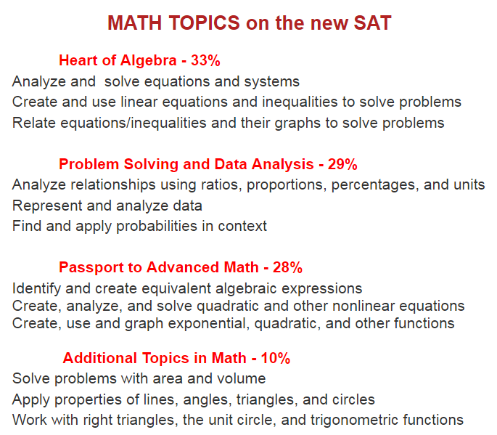
  - Getting Used to new PSAT Scores LINK
    - Dr. Brown provided a handout (see link) which helps to “translate” what a score on the Explore and ACT tests might look like on the PSAT 8/9 and the SAT tests
    - PSAT 8/9 scores top out at 720, while PSAT 10 and PSAT/NMSQT test scores top out at 760 (in each subject, both Math and English); SAT tops out at 800
    - This is dramatically different than the range of scoring for Explore and ACT, which topped out at 25 and 36 respectively
  - Khan Academy LINK to SAT math practice
    - This is a very helpful web site for practicing and strengthening target areas of the SAT
    - From the Khan website, link your PSAT results from the College Board web site to Khan Academy to receive a tailored test prep regimen
- Common Core:
  - The York Math Department has always been comfortable with the Common Core. Other schools have had to change the way they taught math, away from memorization and more toward how to think, but York has always focused on common core principles
- Algebra Two Modeling
  - Dr. Brown spent some time talking about the success of Algebra Two Modeling, a class introduced a few years ago at York to help students who came out of middle school with a need for more applied algebra experience; the course is now an exceptionally effective bridge to Honors level Advanced Algebra Trig or Advanced Algebra Trig for many students who take Geometry as 8th graders or as Freshmen[
  - Algebra 2 Modeling also gives some advantage in the math testing section of the SAT suites
- New textbooks
  - D205 is undergoing textbook reviews across the math curriculum (excluding the Reach and Honors Curriculum at this time)
  - Meetings are being held, and new possible texts will be on display this year for public review at the D205 District Offices
  - D205 has taken care to wait for changes associated with the move to national common core and testing standards to settle in before selecting new books.
  - Unlike in other school districts, the York Math team does not normally select one publisher and opt to purchase an entire series across all four years of high school, preferring to select the right text for each year, regardless of publisher.
  - Full curriculum adoption may not take place in the next school year. They want to do things well, so may not change all textbooks across the board
ALEKS: Overview of ALEKS
  - Dr. Brown then talked about a new technology program being used at York
  - ALEKS started and is still being used as a math placement system for colleges (including COD, University of IL, among others)
  - At use at York now, and next year to supplement instruction
    - Currently deployed in Algebra 2 for Juniors and Seniors as a supplement to the textbook to provide extra problems that can be worked online at home, to strengthen foundational math
    - Will be expanded in its use to Algebra B and Geometry C next year
    - Outline of high school topics
- Summer School :
  - Dr. Brown noted that registration for summer math courses will require Math Department approval in advance, to ensure families are making the right decision about summer math
  - In the past, some students were poorly fitted for summer classes
  - Summer math courses (see the color coded flowchart)
    - Summer Algebra B (to follow full year of Algebra A; would allow a student to accelerate into the Algebra B/Geometry path
    - Summer Geometry (to follow a full year of Algebra AB) – would allow a student to move up to Algebra 2/Modeling, if successful
    - Summer Precalculus is designed to accelerate juniors who are strong students in Advanced Algebra/Trig H so that they have the Precalculus background to take AP Calculus AB as seniors. The summer course is not taught at the honors level due to the compressed time frame.
MATH PATHWAYS COURSES
- Courses & flow : view individual pathways OR structure of the courses LINK to Pathways for Math Courses 2017-18
  - New Course for 2017-18
    - Functions/Finite Math H, which may be taken after PreCalc from 2 different tracks
      - Will be Advanced College Project (ACP) with Indiana University
  - New Course for 2018-19
    - Advanced Topics are under development, but MAY include
      - Calculus III
      - Applied Math
      - Proofs

Discussion and Q&A:
What is the difference between AP Calculus AB and AP Calculus BC?
- AP Calculus AB is considered the equivalent of one semester of Calculus in college. The next course in the sequence in college would be Calculus II
- AB Calculus BC is considered the equivalent of one full year of calculus in college and covers all the material covered in AP Calculus AB and additional topics. The next course in the sequence would be Calculus III.
Should my student always go for the higher level math course or Honors level course?
- Dr. Brown counseled that students should match coursework to their facility with the prior math content and material. If student has fully mastered the material, it is always a good idea to move up and/or tackle the next level. However, students sometimes overreach – moving onto the next level before s/he has strong knowledge base. This can stress students emotionally and intellectually, hurt your test scores and grades, and actually hurt your math acumen or readiness for college. Prioritize math courses that prepare you to THINK in college, vs. focusing on simply moving through coursework to attain a certain, perhaps arbitrary level.
What math courses should students interested in computer science focus on?
- According to computer science teachers at highly competitive universities, strong content knowledge in math is more important to success in Computer Science than having taken computer science coursework in high school. Certainly students can/ may do both, but continue in math to be successful in Computer Science.
- Enriched Adv Alg Trig Honors uses computer programming heavily (True Basic). Enriched PreCalc H/AP Stats has limited computer programming as the curriculum has less time for it
What careers benefit from a strong foundation in math?
- This web site was suggested: http://weusemath.org/careers/

